440M

JERZEES
Pique Knit
Sport Shirt

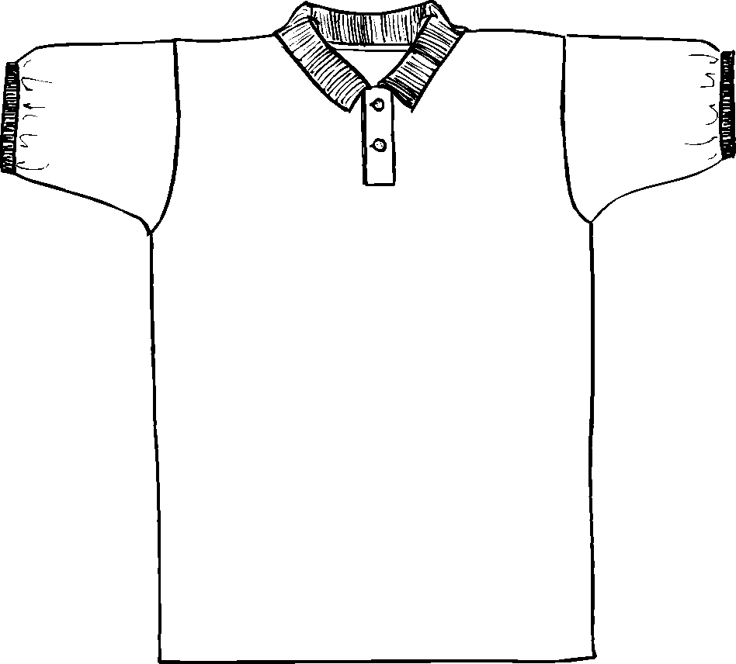

Descriptions
*100% Combed cotton, 6.5 ounces
*Welt collar and cuffs
*2 Button horn tone buttons
*Double needle bottom hem
*Embroidery only

Finished Garment Measurements

Size | S | M | L | XL | 2XL | 3XL | 4XL
Width 1” under armhole | 19 ½ | 21 ½ | 23 ½ | 25 ½ | 27 | 28 ½ | 29 ½
Length from shoulder point | 29 | 30 | 31 | 32 | 33 | 34 | 35
Sleeve Length from CB | 11 5/8 | 11 5/8 | 11 ¾ | 12 ¼ | 12 ¾ | 13 ¼ | 13 ¾
Shoulder Width | 17 ¾ | 19 ¾ | 21 ½ | 22 ½ | 23 ½ | 24 ½ | 25 ½

